RE: «Student_First» «Student_Last»

Parents,

Your student has enrolled in the Competency Based Mathematics program through Truman State University. We would like to provide you with some information on how to assist your student in setting up an account with Truman. This account will allow you to make online payments, view their grades and request a transcript once they have completed the course.

This document will also provide information about the Hawkes Software and how to get started. Please read through all the information carefully before beginning.

If you have any questions, please contact us at 660/785-5384 or email aowen@truman.edu.

Instructions to setup your account and create a password

To set up your student’s Truman account and create a password, you will need the information below:
Your student’s username is «Username» and their Banner ID# «ID»

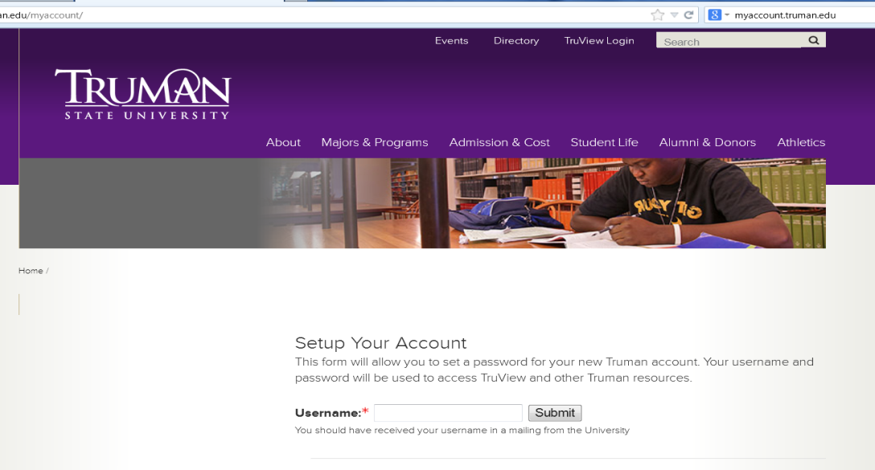
- Go to http://myaccount.truman.edu. You will see a screen that looks like this.

- Type your username in the box indicated. Your username can be found above. Your initial username will consist of a combination of letters and numbers and is unique to you alone. It will probably look something like “abc1234” and usually represents your initials followed by a random set of digits.
- Click “Submit”. The following screen will appear and you will now be able to setup your account.
To Set up Your Account
- Your Truman-assigned user name will appear in the username field. Type your Truman ID number or Banner ID in the field “Truman ID Number (Banner ID).” This number can be found on the previous page.
- Use the drop-down menus to insert your birth month and day. Make sure to put the full four-digit year of your birth.
- Enter the last four digits of your social security number. If you did not provide Truman with a social security number on your application, you will need to enter the four digits of your year of birth instead.
- You will then need to create a security question. This question can be used to reset your password if you’ve forgotten it. Select a question from the drop down menu. Next type the answer to your security question in the answer field.
- Finally, at the bottom of the page, create a new password following the instructions given. Click “Set Password” to complete this final process.
- If you receive an error message that says “your information does not match our database”, you probably did not submit your social security number to us on your application. You will need to go back and enter your year of birth in the Social Security field instead. If you still receive the message, you will need to contact our IT Help Desk at 660/785-4544 for assistance.
- Once you’ve completed this process you are able to access the full services of TruView. Visit http://truview.truman.edu to make a payment or view your account.
Tuition Due
The tuition due for Competency Based Math is $300 and the full amount is due by October 15, 201_ unless you are on the flexible payment plan.

No paper bills will be sent to your home address. All bills will be posted on TruView and emailed to the student’s Truman email address, accessible through TruView, and/or the email address of the Authorized User. (see below about Authorized User access)

To make a payment to your student’s account, the following options provide students and their families with maximum flexibility at the lowest possible cost.
- Pay by check or money order – Make checks payable to the Truman State University and include your student’s name and Banner ID# (Truman ID number) in the memo section. Mail to Truman State University, Student Account Payment, PO Box 754, Kirksville, MO 63501. There is no fee for this option.

- Pay by e-check, an electronic debit to a checking or savings account, available online at mybill.truman.edu for authorized users or via TruView for students. There is no fee for this option.

- Pay by MasterCard, Visa, Discover or American Express credit card online at mybill.truman.edu (authorized users) or via TruView (students). Credit Card payments can only be taken online and will be charged a 2.75% convenience fee by TouchNet Information Systems, a secure third-party transaction vendor. Credit card payments by telephone, mail or at the Cashier Window in McClain Hall will no longer be an available payment method; however, debit cards with pin will be accepted at the Cashier’s Window.

To Make a Payment
You have two options to pay online:
- Your student can authorize you as a user on their student account as well as any other friends or family members who may be assisting with payment of your student’s tuition fees. (see enclosed instructions to setup an Authorized User)
- You may also login in as your student but will need their login and password in order to do this so that you can view their account and make a payment.
- Go to http://truview.truman.edu and log-in. Click the Student Tab at the top.
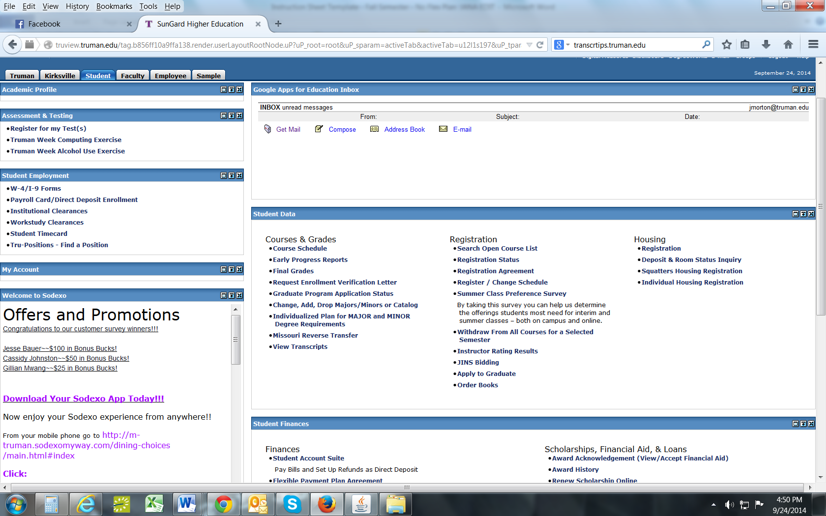
- In the Student Finances box, click on Student Account Suite. It will then direct you to the following My Account screen where you will be able to view your account balance or make a payment. To make a payment, click on the green “Make a Payment” tab.
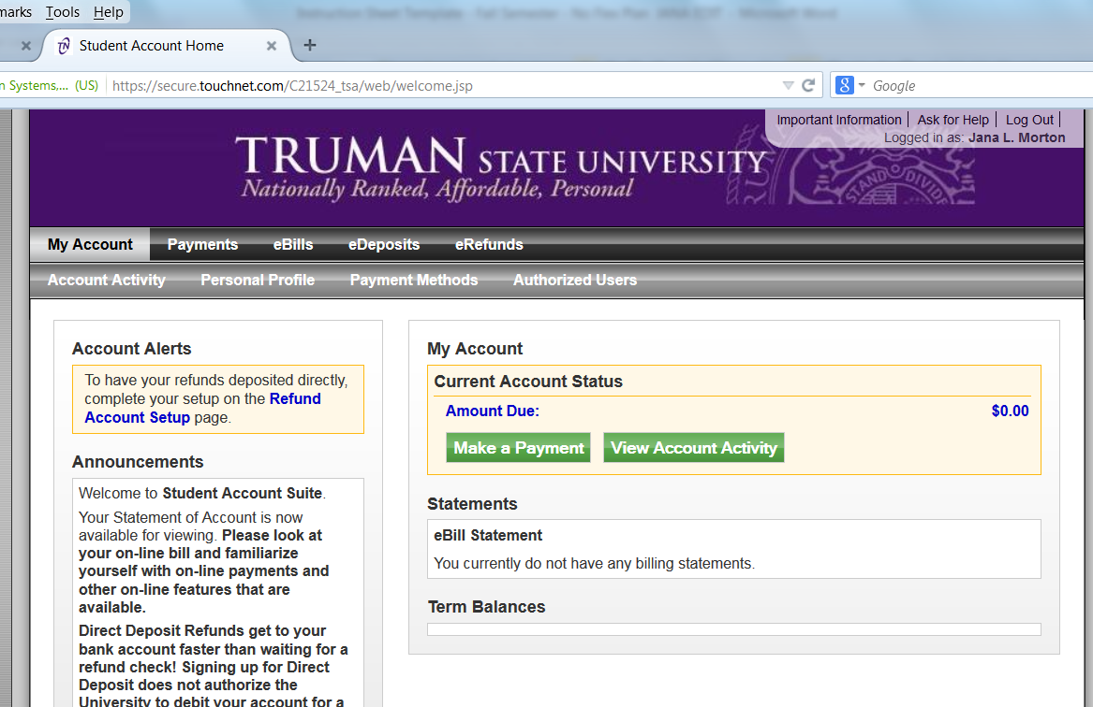

- Your amount due will appear on this screen. Click on the green “Make a Payment” again to go the payment screen.

- You will see this screen.
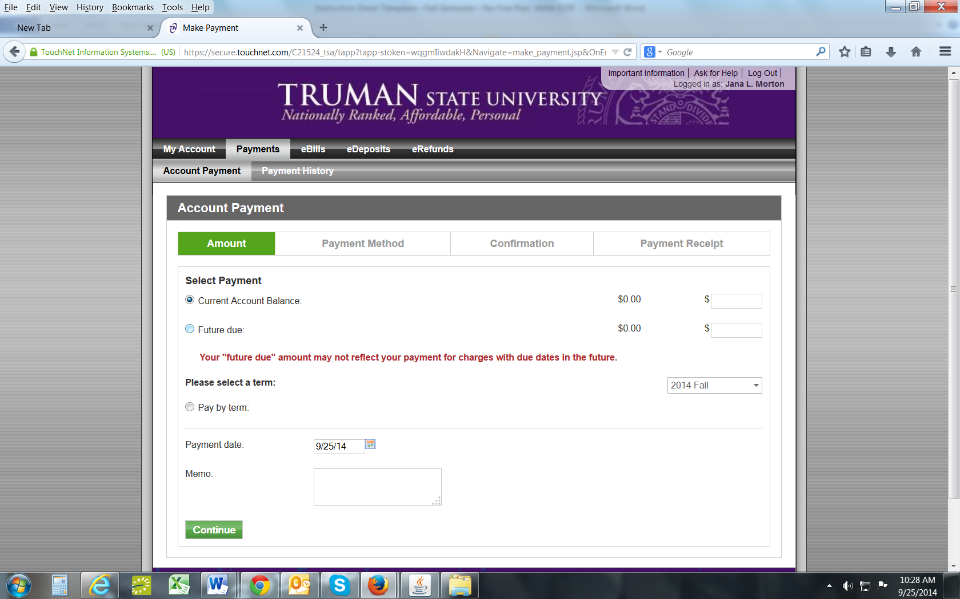

- Make sure that you select “Current Account Balance” to make your payment. Please DO NOT select “Pay by Term” option.
- Enter the amount you want to pay.
- Make sure that current term is listed.
- Click “Continue”.

- Select your payment method from the drop down box and continue with the payment process following the instructions listed.
- Make sure to print out your receipt as you will not receive one in the mail from us.
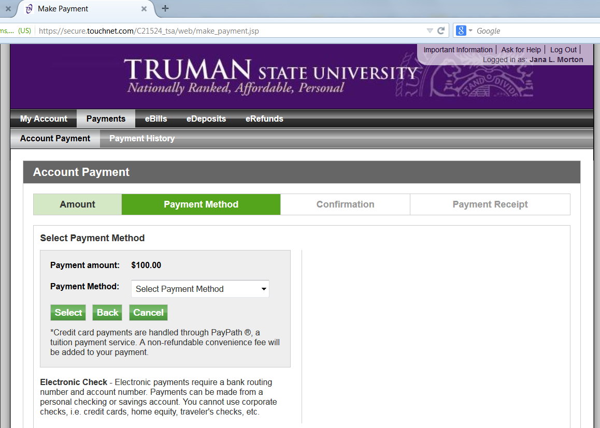

Set up Authorized User
To set up an authorized user your student will need to do the following:
- Go to http://truview.truman.edu and log-in.
- Click the Student Tab at the top.
- In the Student Finances box, click on Student Account Suite. It will then direct you to the My Account screen.
- Click on the My Account tab, this will reveal a drop down menu. Click on the tab Authorized Users at the top. Follow the instructions to add authorized users email addresses for parents/others who need access to your on-line bill.
- Click “Continue” to confirm this information.
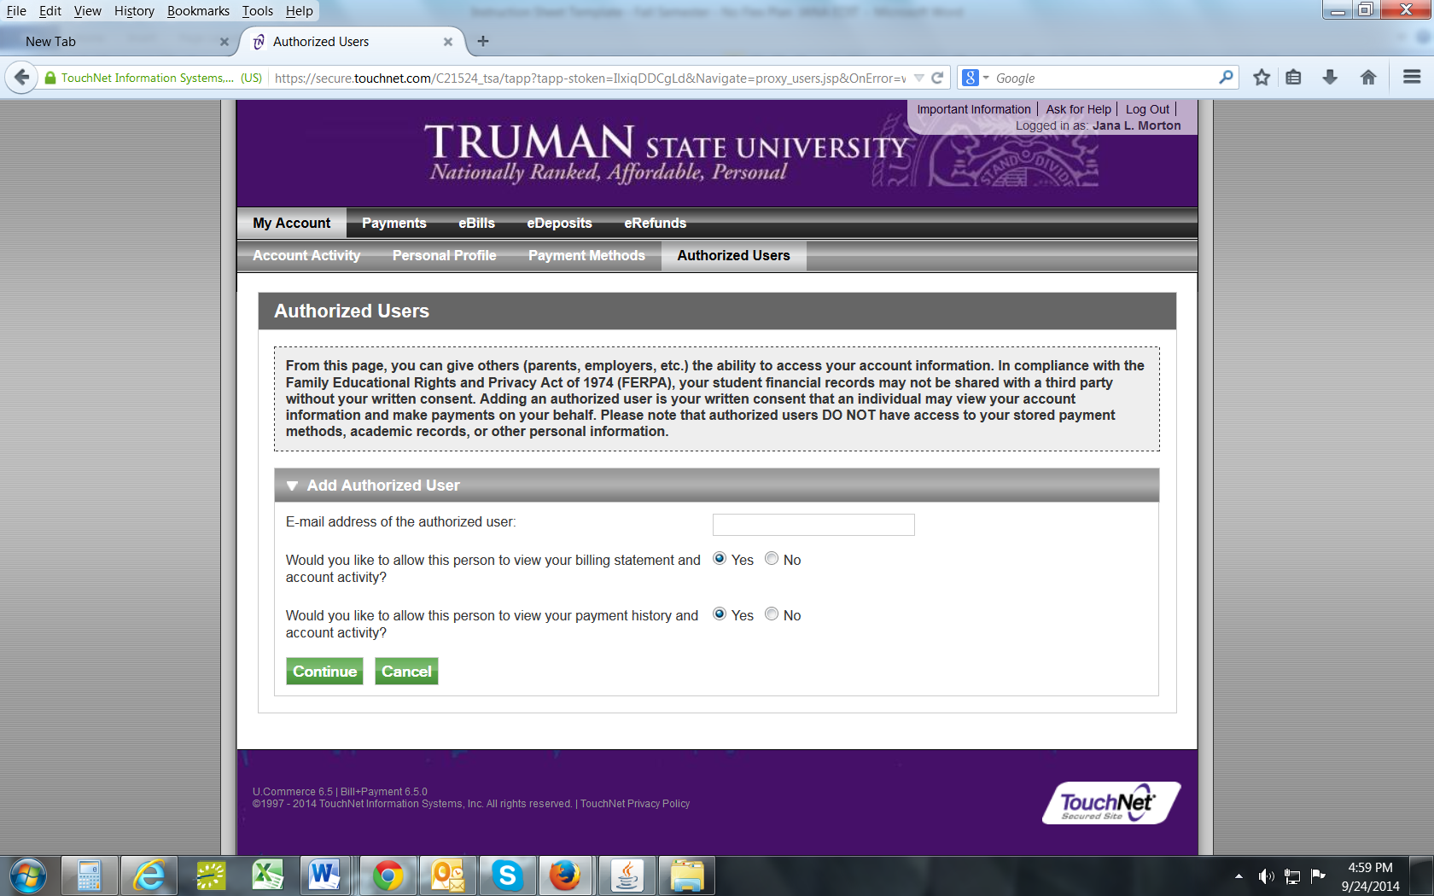

- You will see this screen:
- Read the Agreement to Add Authorized User and if you agree to the terms, click “I Agree” and then click “Continue”.
- You may print a copy of this agreement for your records.
- After you click “Continue”, you will get a confirmation of the authorized users you have added.

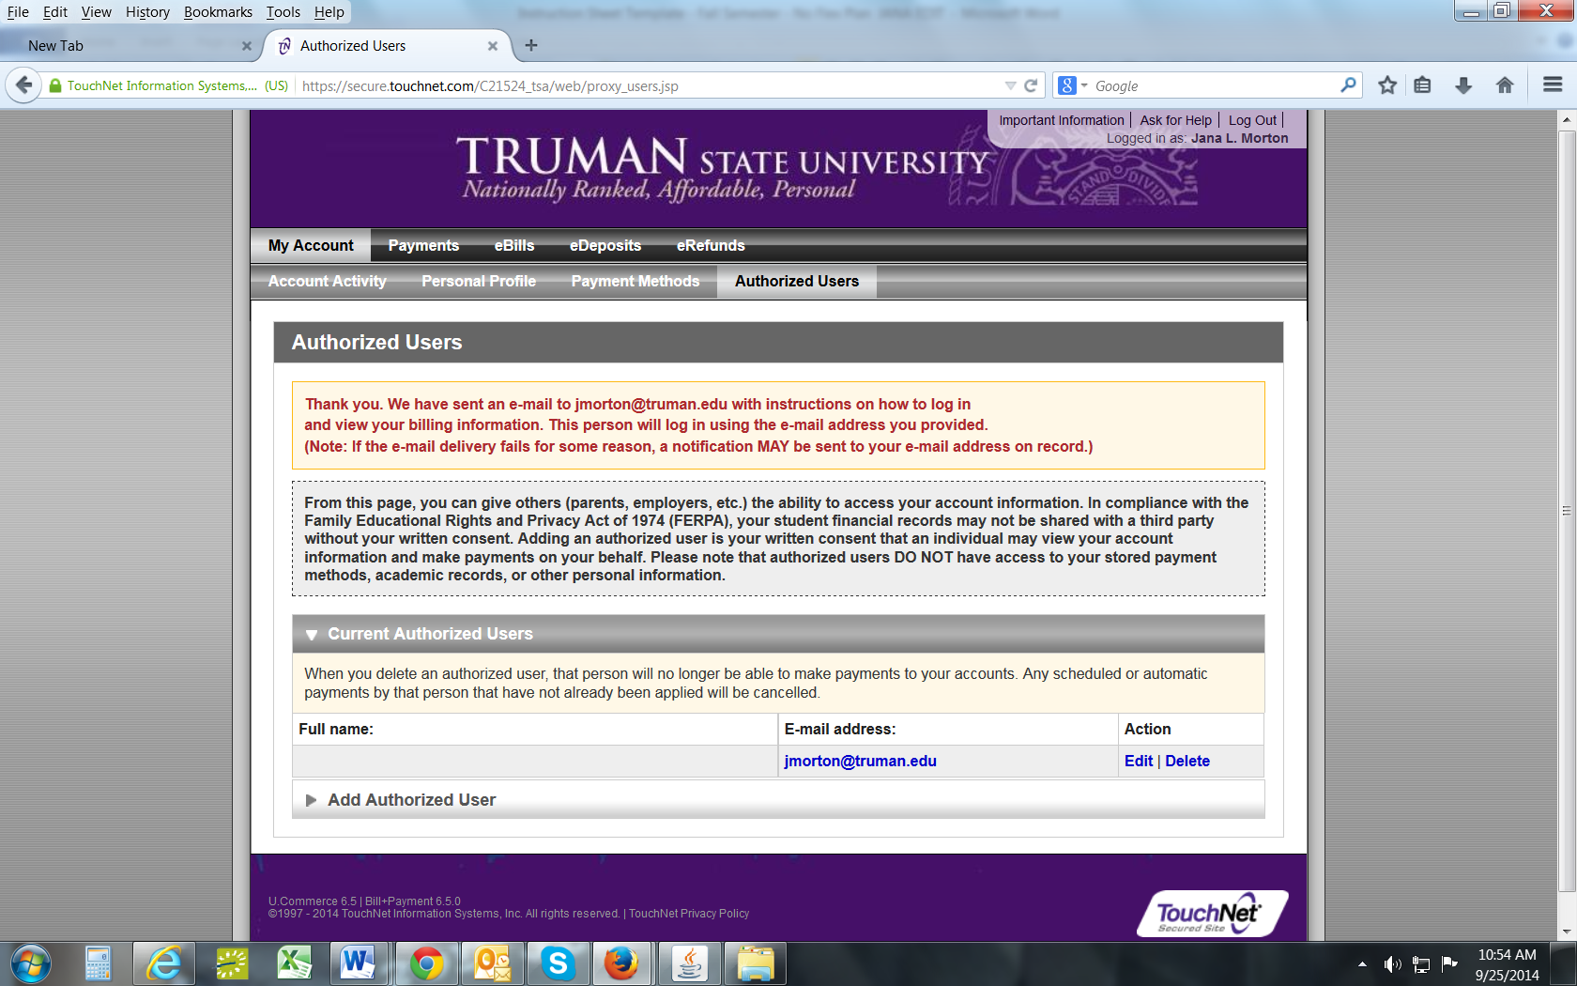

Submit your Social Security Number securely online (Required Before Transcripts Will Be Released)
- Log in to TruView: https://truview.truman.edu.
- Go to the Truman Tab
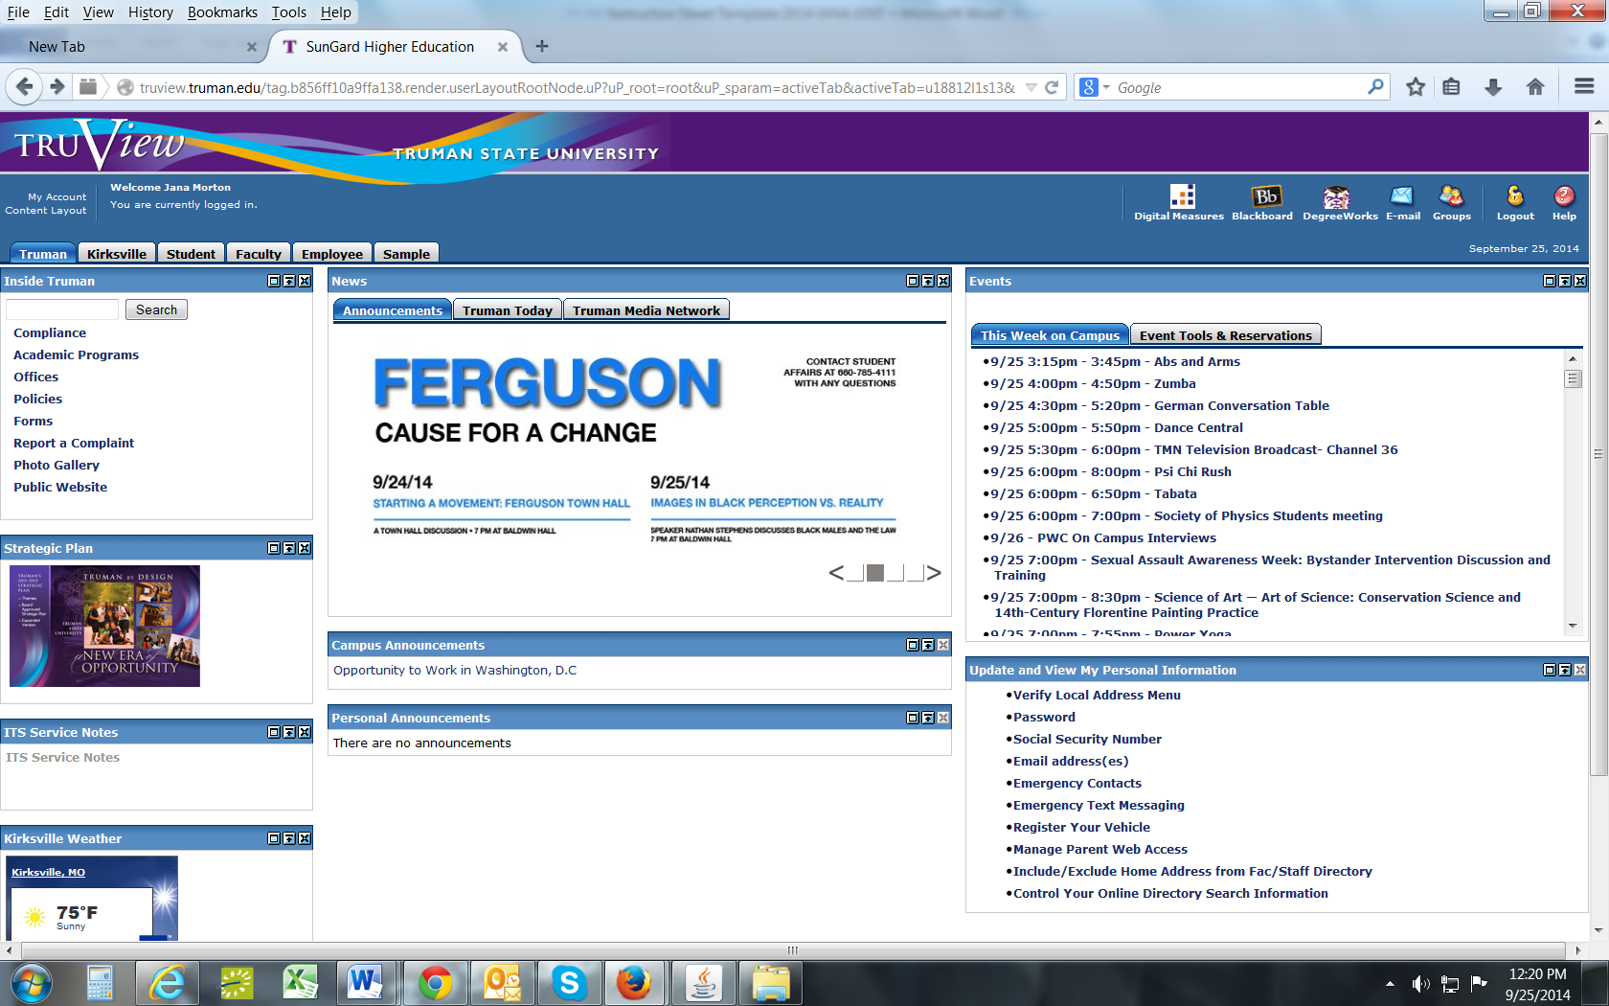
- In the Update and View my Personal Information box, click the Social Security Number link. It will prompt you to enter a SSN. You will then need to enter it again to confirm it.
- Click “Submit”.
To View Grades & Request Transcripts
After completing the course, you will have the option to request a transcript once grades have been posted.
- To view your account to see if your grade has been posted, login to TruView.
- Click on the Student Tab.

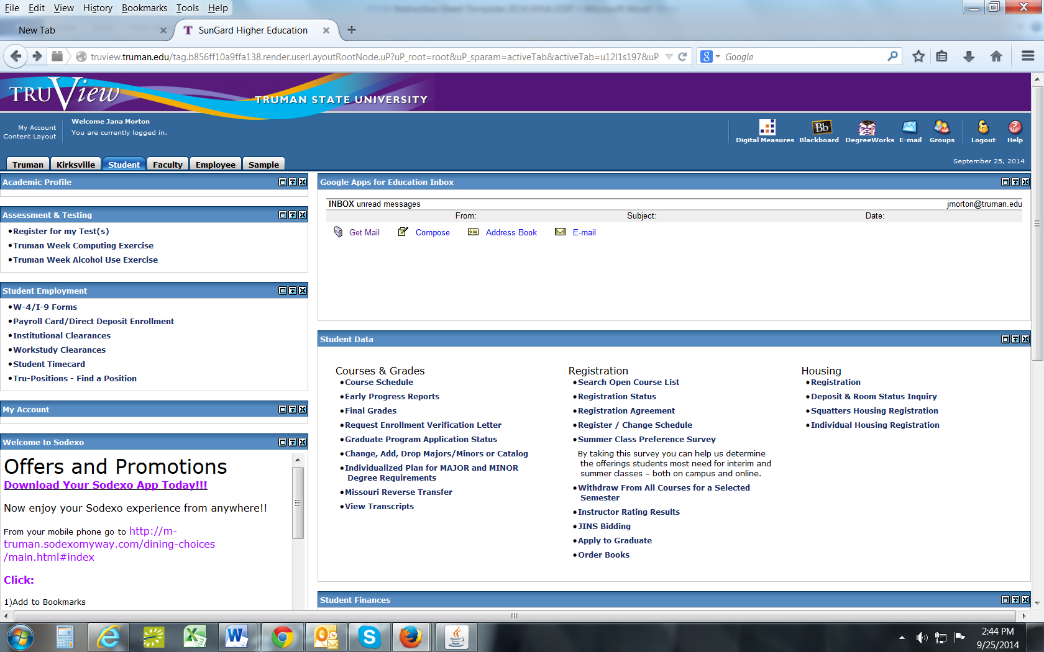

- Under Student Data click on the link “Final Grades”.
- You will either be able to see your posted grades or you will see a message that says “No grades on your record are available”.
- Once your grade is posted there, visit http://registrar.truman.edu to request your transcript.
Information about the Hawkes Software

Get your Access Code for the Software Program
- Go to https://www.hawkeslearning.com/Support/GetYourAccessCode/Makacode.asp
- Fill out the form using the same first and last name that you entered on your application
  - Use the following 15-digit license number: «Software_License_Number»
  - Select Truman State University as the school
- Your personalized Access Code will be displayed on the screen and sent to you via email.

Download the Software Program
- Go to http://www.hawkeslearning.com/Support/Downloads.htm
- Select “Precalculus” from the drop down menu
- Click the “Student Compact Install for PC” link and then “Run”
- When prompted for the Hawkes Course ID enter: Truman PRC

Enroll in Your School’s Section of the Course on the Software Program
- Open the software program
- Type or paste in your access code and select “OK”
- Save your access code onto a USB device you can use the “Load from file” option to log in later.
- Choose your instructor and section from the drop down menus and select “Enroll”

If you have any problems or questions about the software, please contact:
Vanessa Williams
Email: vpeach@truman.edu
Phone: 660/785-4090

