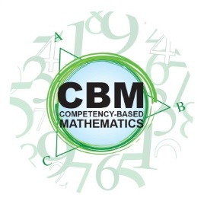

Competency-Based Mathematics
Proctor Pre-Approval Form

Student Name |  |  | Proctor Name
Proctor’s Work/School Email
Proctor’s Phone
Proctor’s Institutional Affiliation (Ex: Jones Elementary School)
Proctor’s Work Title (Ex: Math Teacher, Principal, Librarian)
Location Where Exam(s) Will Be Administered (Ex: Jones High School)
Do you (the proctor) have access to a computer with the minimum necessary properties necessary for the student to take their exams? (Requirements listed on the back of this form). |  |  |  | Yes |  | No
Are you (the proctor) related in any way to the student who has requested you proctor their exam? |  |  |  | Yes |  | No
Do you (the proctor) have any other relationship with this student that would represent a conflict of interest in objectively proctoring this student’s exams? |  |  |  | Yes |  | No
By signing below, I affirm that I have truthfully represented my identity, institutional affiliation, and absence of conflicts of interests with the student requesting proctoring services. I agree to abide by the policies and procedures of the Competency-Based Mathematics Program at Truman State University as described in the document “Proctoring Policies and Procedures.”
Signature |  |  | Date
Please return this completed form to:

The Institute for Academic Outreach
Truman State University
100 E. Normal Ave
Kirksville, MO 63501
(660) 785-7202 - FAX
institute@truman.edu - EMAIL

Proctoring Computer Requirements

Students will need to complete their examinations on a computer at the proctoring site. This computer should not be their own computer. They will be accessing the software to take the exam via the web. The computer they use must meet the following minimum standards.

- Windows XP (with Service Pack 3)
- Mac OS X v10.6 or later, Intel x86 systems
- 1Ghz or faster processor
- 512MB memory (RAM)
- 500MB hard drive space (compact install), or up to 1.5GB (complete install)
- One of the following web browsers:
  - Internet Explorer 6.0
  - Mozilla Firefox 2.0
  - Safari 3
  - Google Chrome 2.0

